**Installation of Docker daemon in a linux host**

1. update your existing list of packages

apt-get update && apt-get upgrade -y

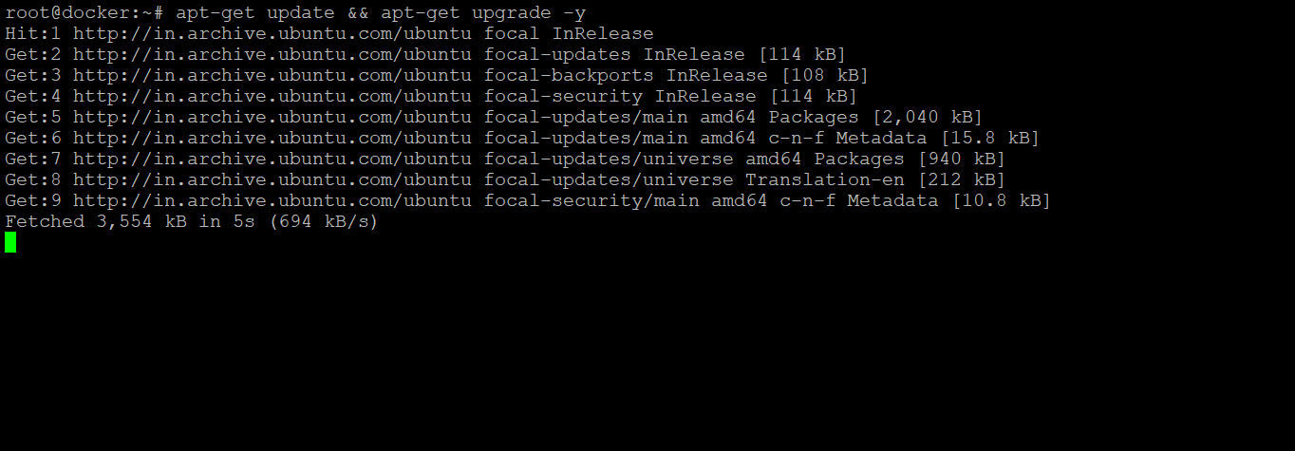

1. install a few prerequisite packages which let apt use packages over HTTPS

apt install apt-transport-https ca-certificates curl software-properties-common

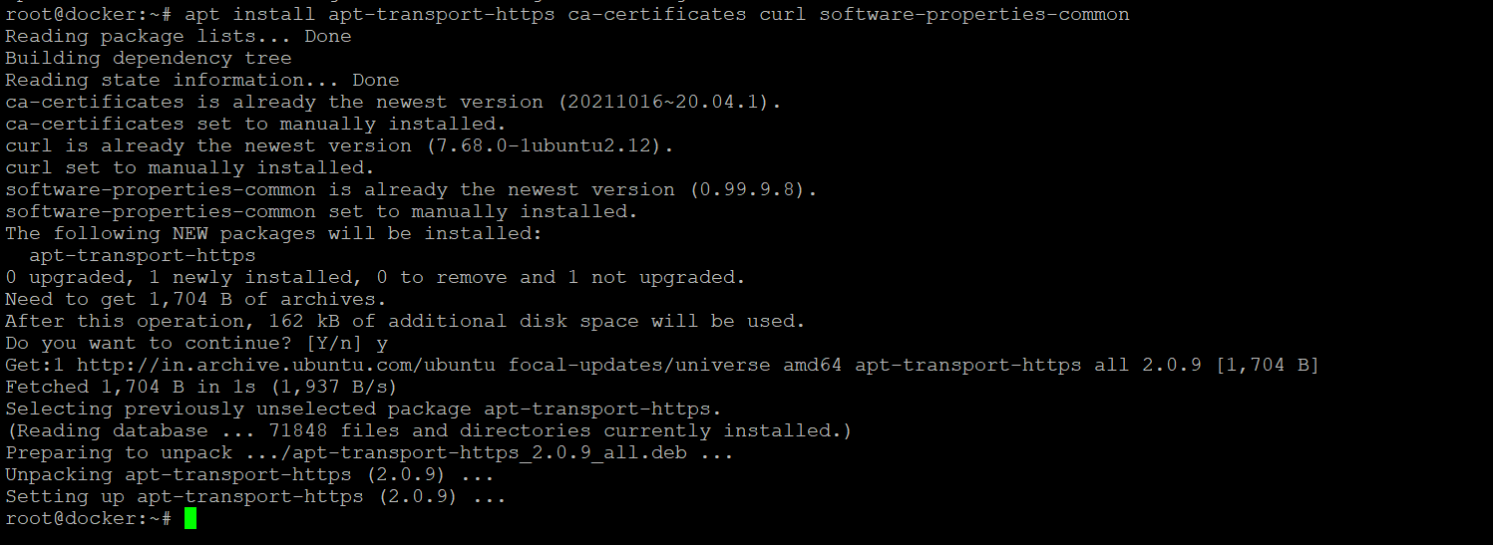

1. add the GPG key for the official Docker repository to your system

curl -fsSL https://download.docker.com/linux/ubuntu/gpg | sudo apt-key add -



1. the Docker repository to APT sources

add-apt-repository "deb [arch=amd64] https://download.docker.com/linux/ubuntu focal stable"

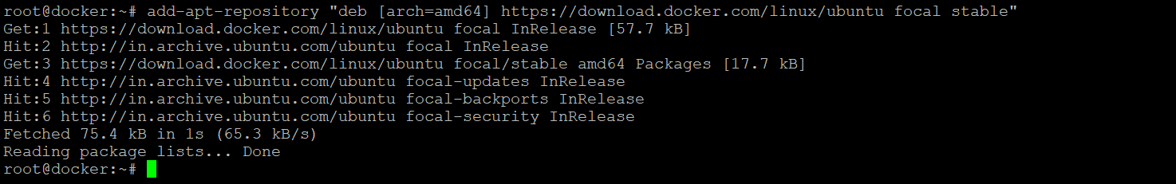

1. Make sure you are about to install from the Docker repo instead of the default Ubuntu repo

apt-cache policy docker-ce

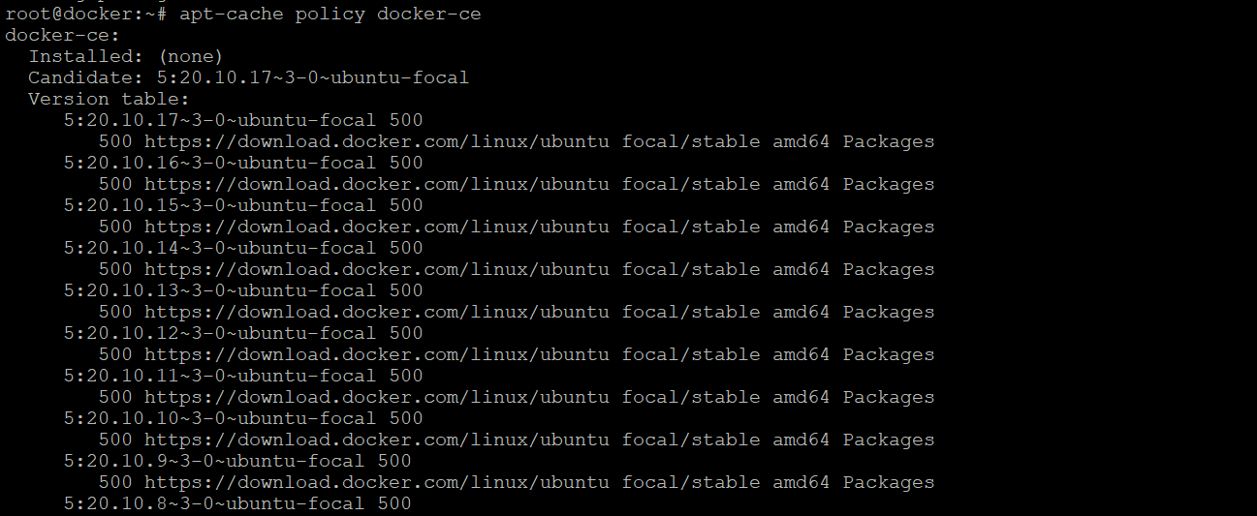

1. install Docker

apt install docker-ce

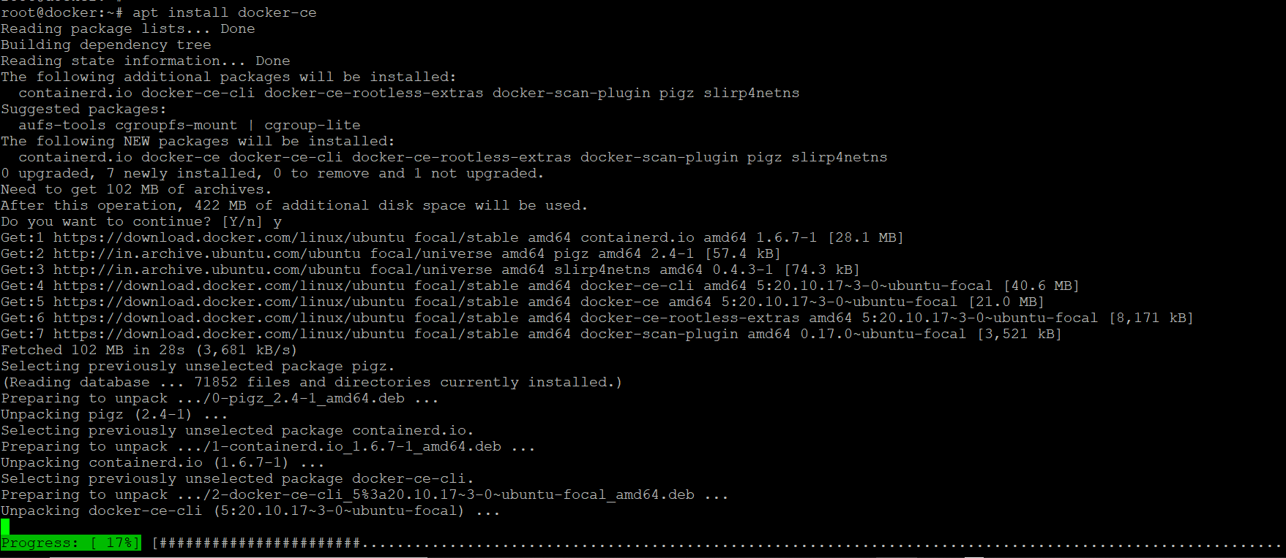

1. Docker should now be installed, the daemon started, and the process enabled to start on boot. Check that it’s running

systemctl status docker

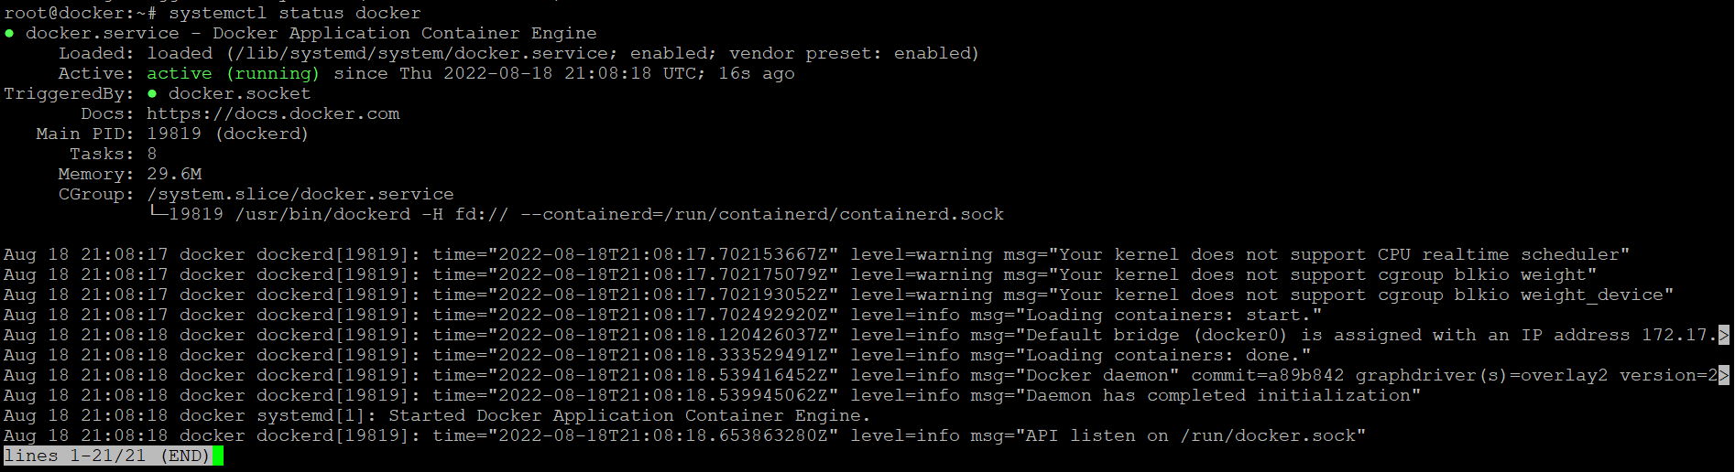

**Docker command line**

To view system wide information about docker use the following command

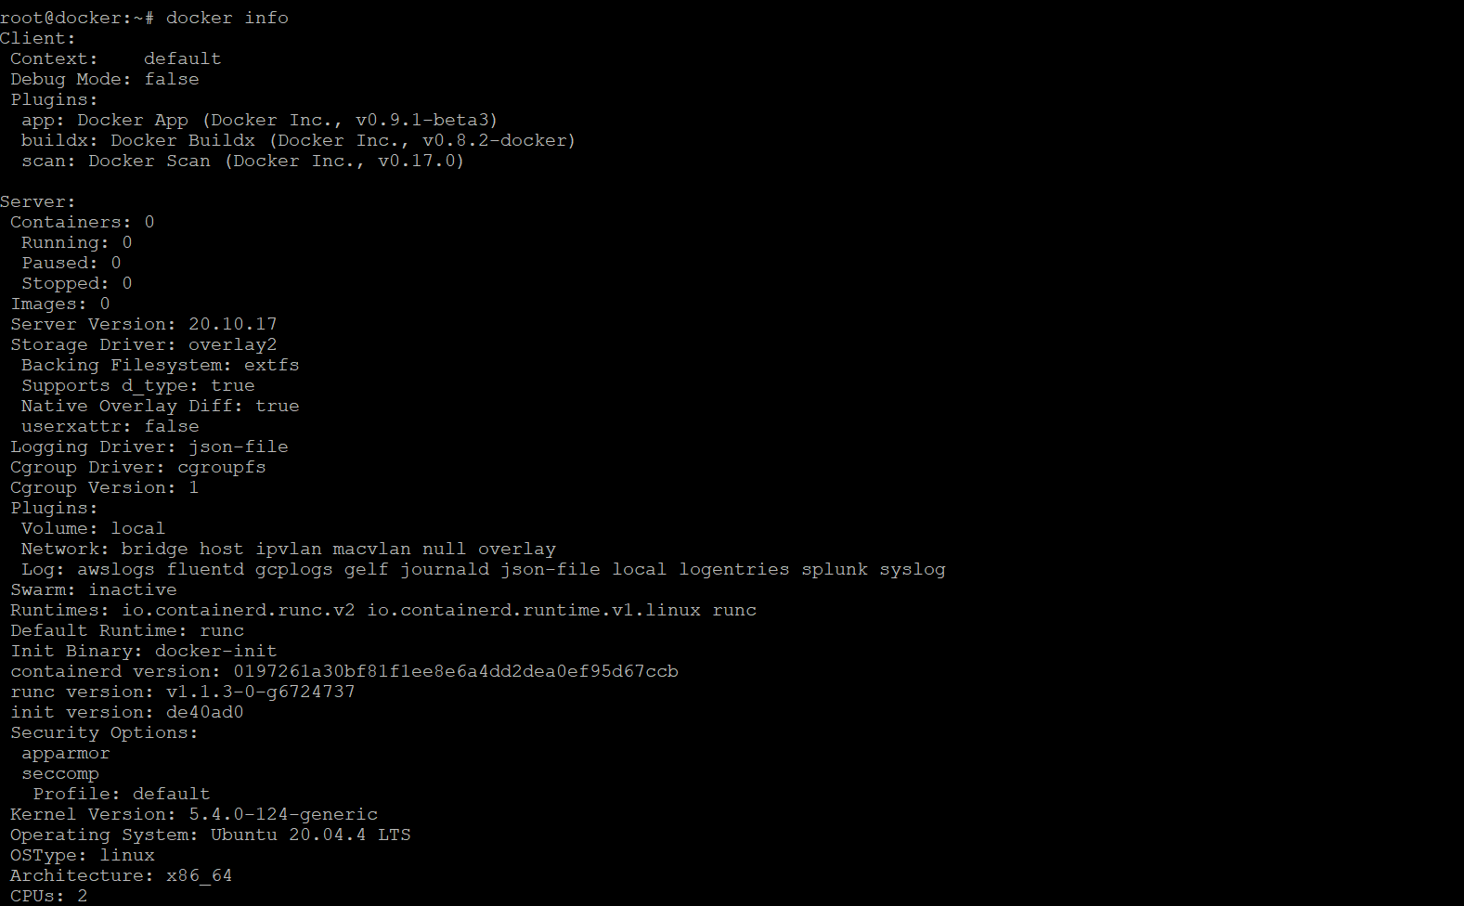

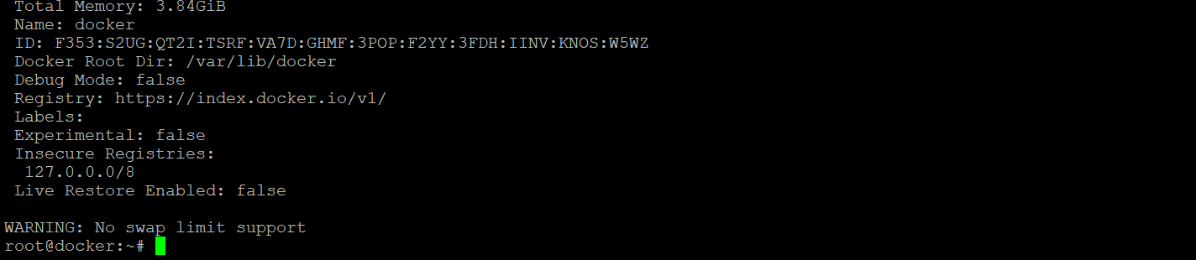

To run your first docker container, use the following command:-

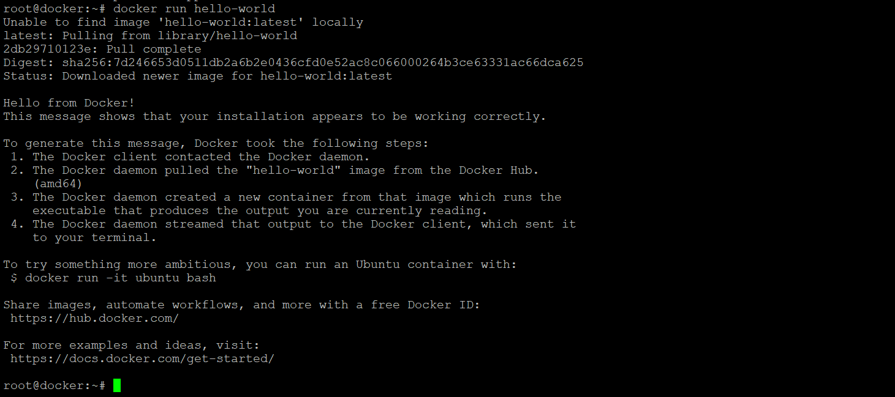

To search images available in a docker hub, use the following command:-

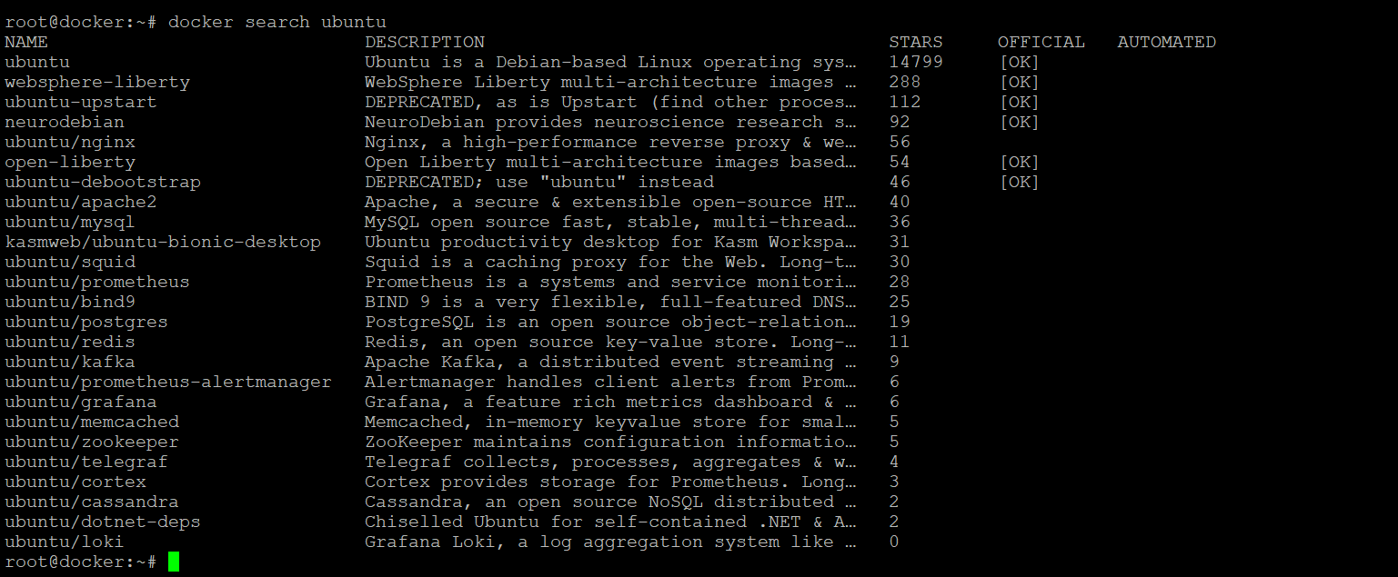

To download the official ubuntu image to your server, use the following command:-

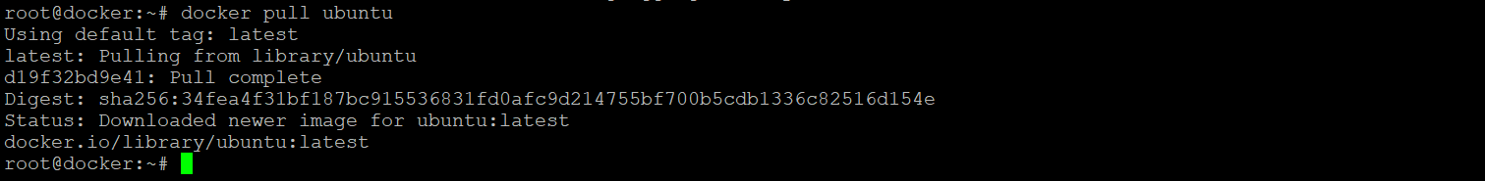

To see the images which have been downloaded to your server, use the following command:-



To list the running containers in the server, use the following command:-



To list all the containers whether they are in a running/stopped/pause state, use the following command:-



To view the latest container which we created use the following command:-



To start a stopped container, use the following command:-

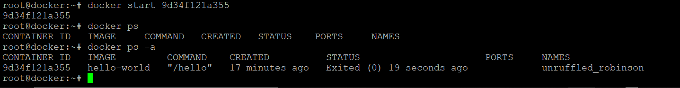

To stop a running container, use the following command:-



To remove the container, use the following command: -

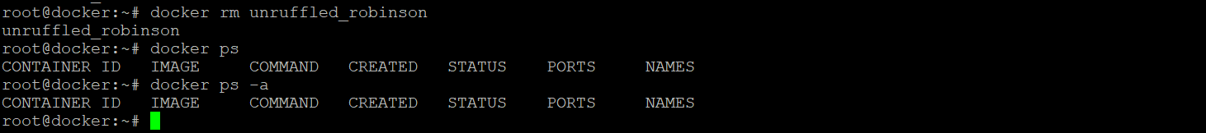

To remove the images from host repository, use the following command:-

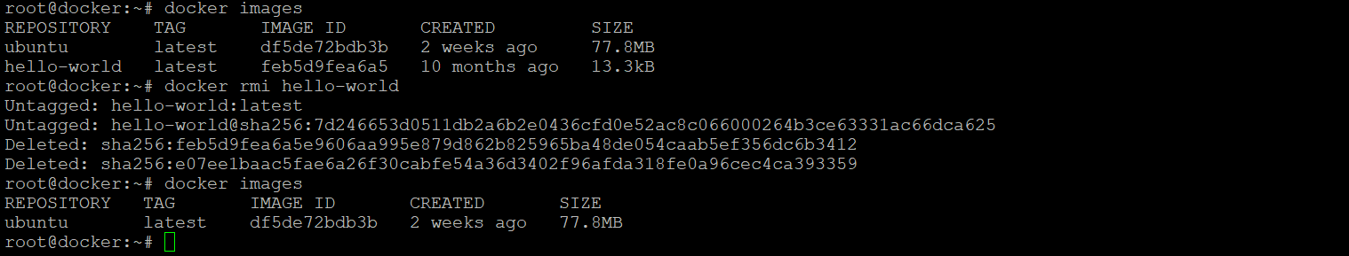

To commit changes in a container to a docker image, use the following command:-

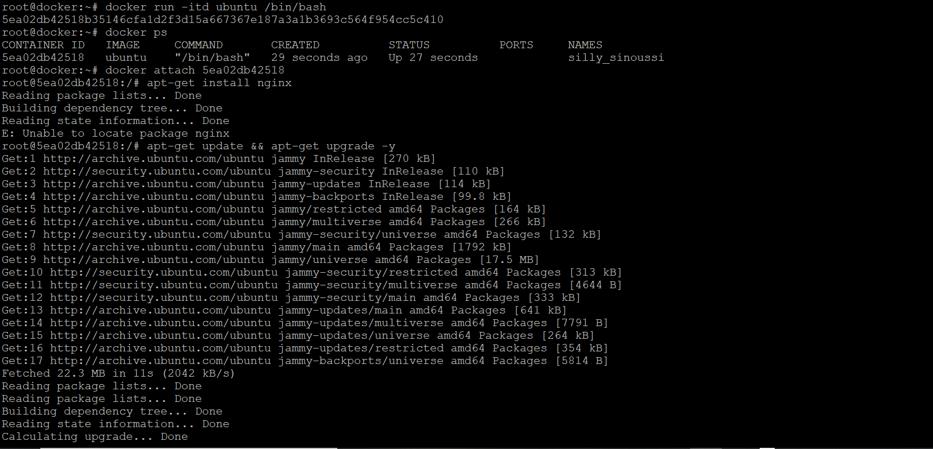

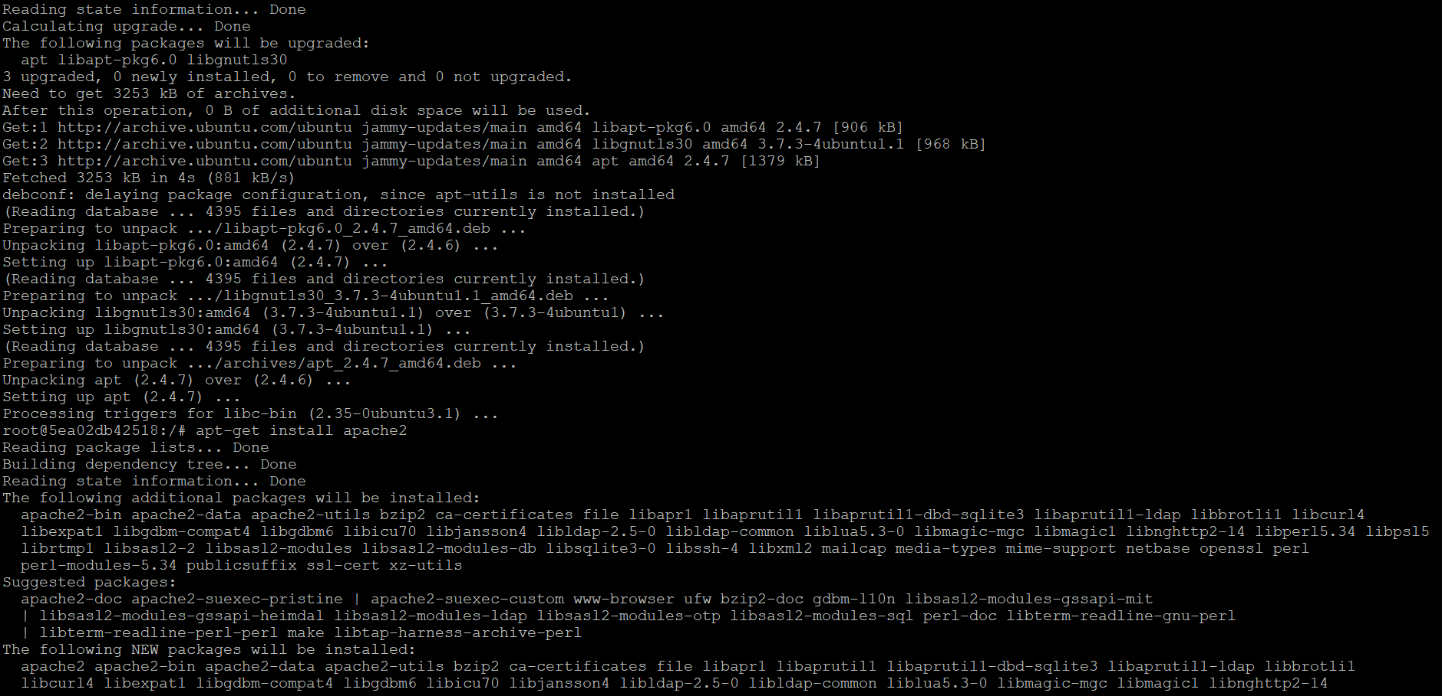

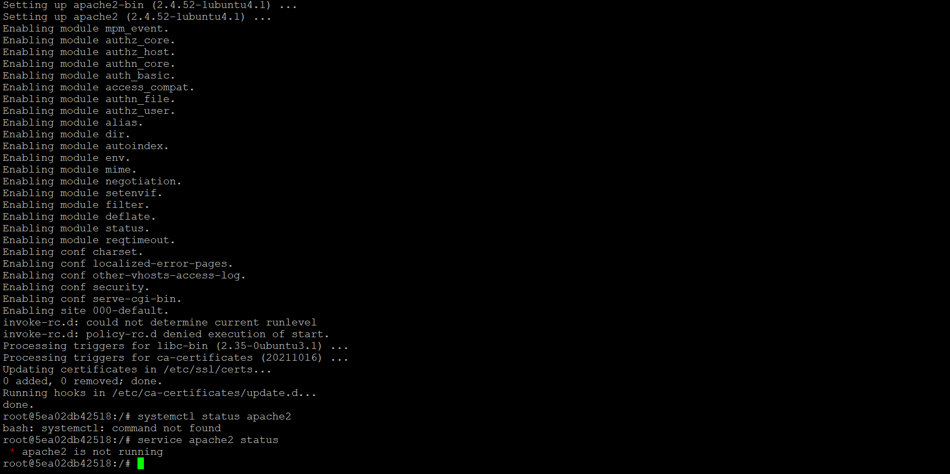

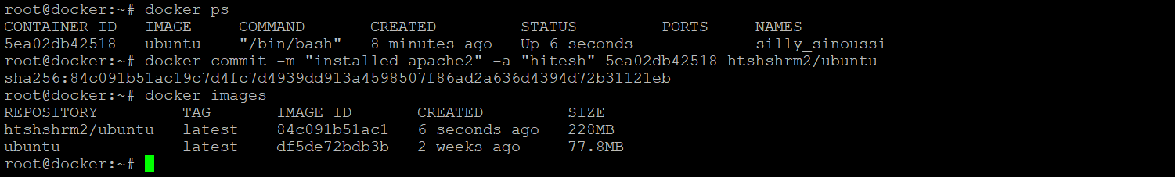

To push the docker image to the docker hub repository, use the following command:-

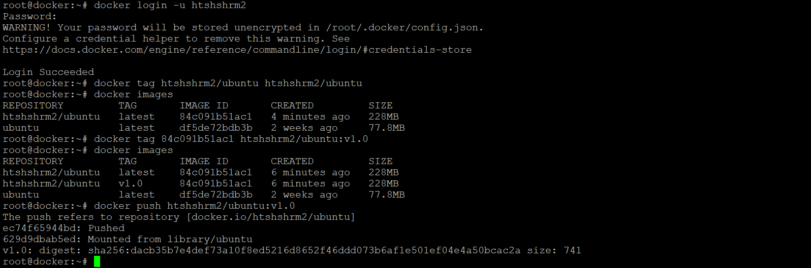

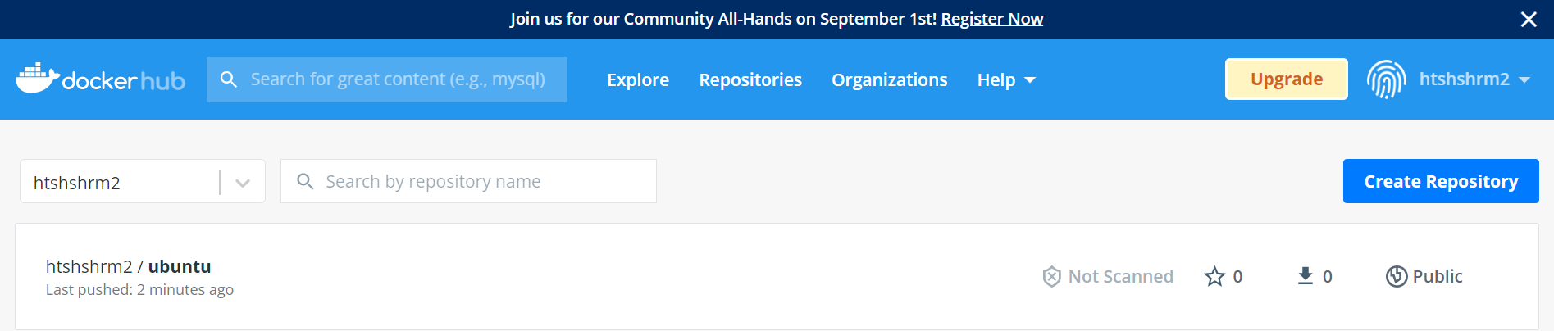

To ssh into a running container, use the following command:-



To restart a container, use the following command:-

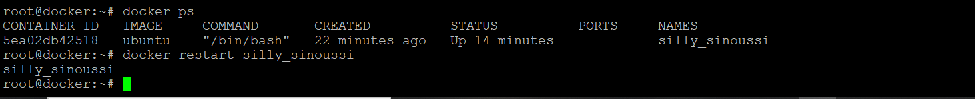

To check the CPU and memory utilization of all the containers, use the following command:-





To check the disk space utilization of host, use the following command:-

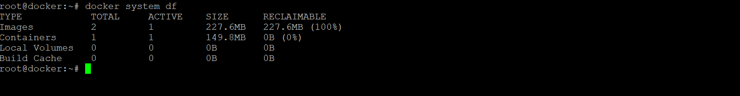

To remove all unused images, containers, networks and volumes, use the following command:-

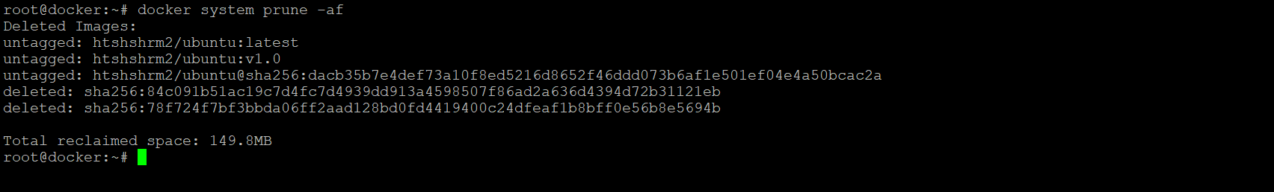

To show the logs of the container, use the following command:-

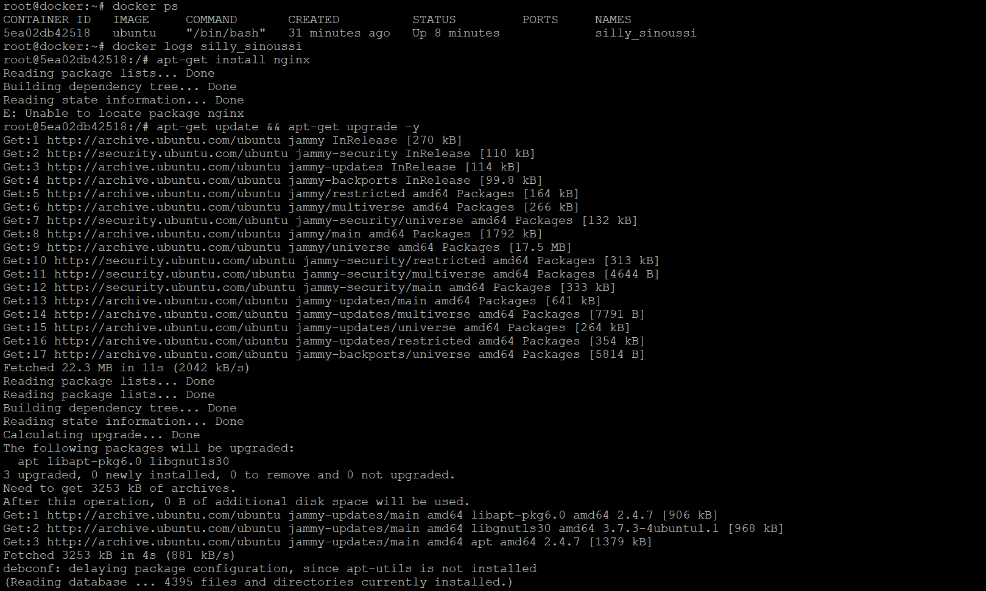

To show processes of a running container, use the following command:-



To get details about the installed docker version, use the following command:-

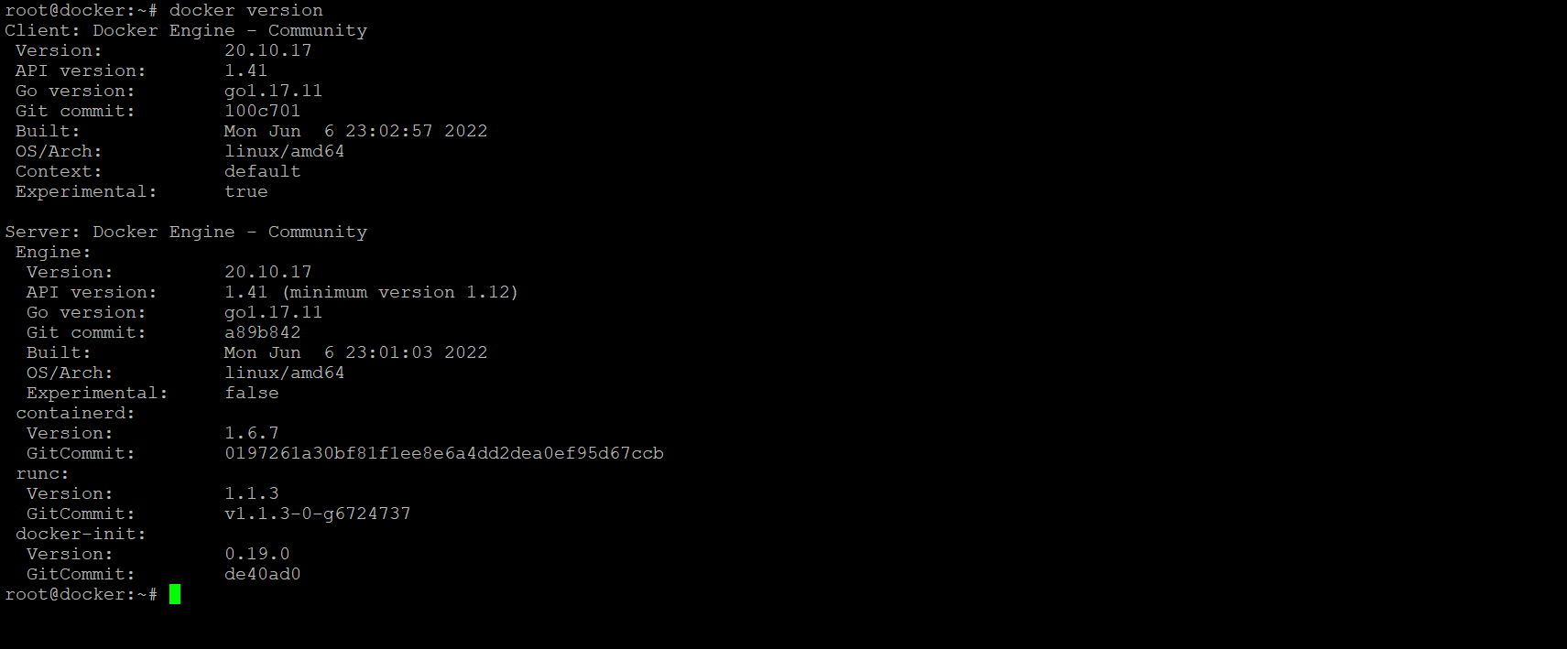

To get details about any object, use the following command:-

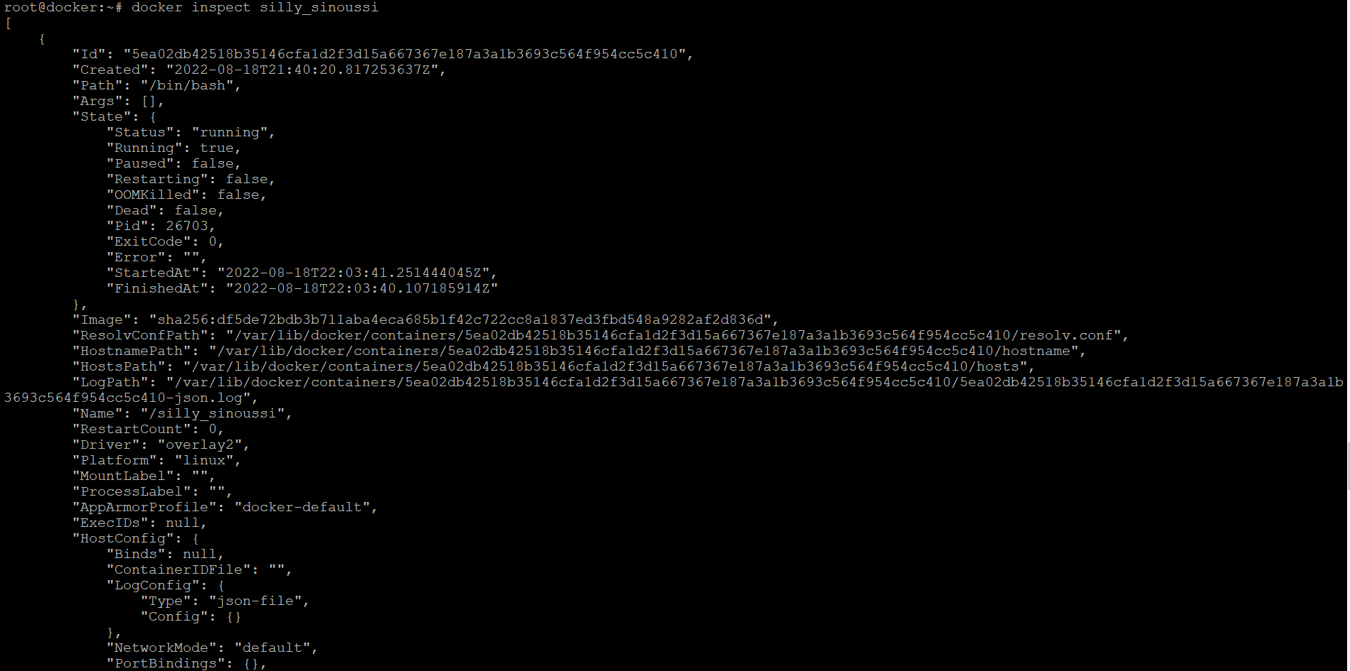

To show all modified files in the container, use the following command:-

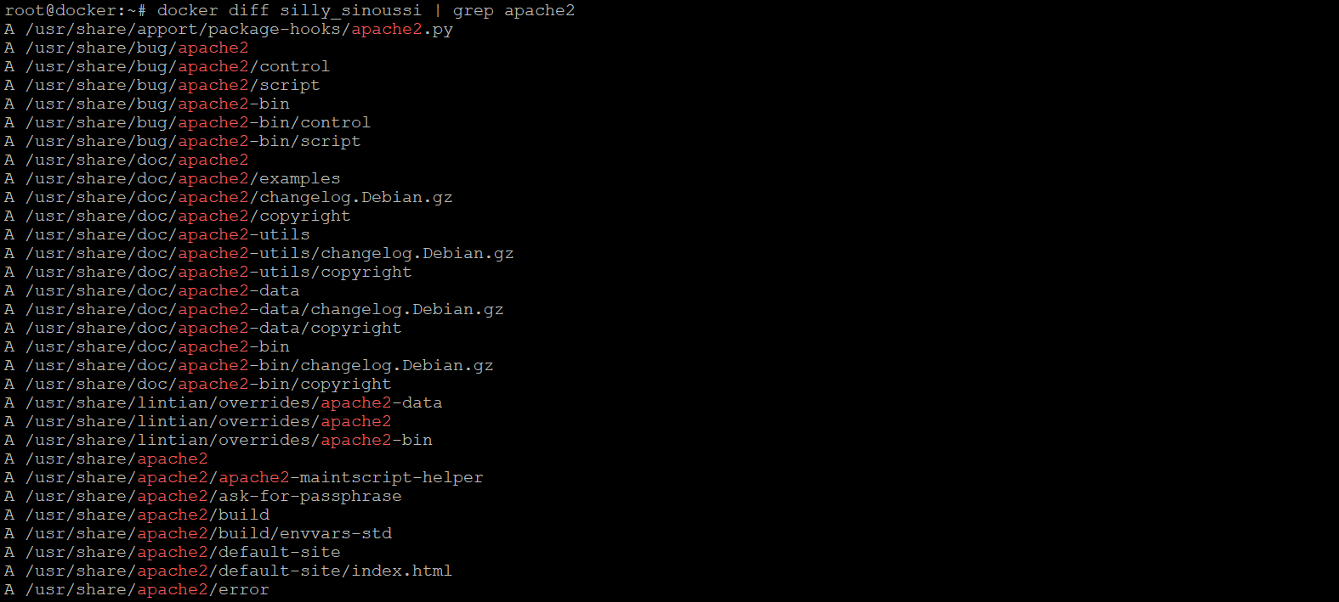

To map host ports to the container ports, use the following command:-

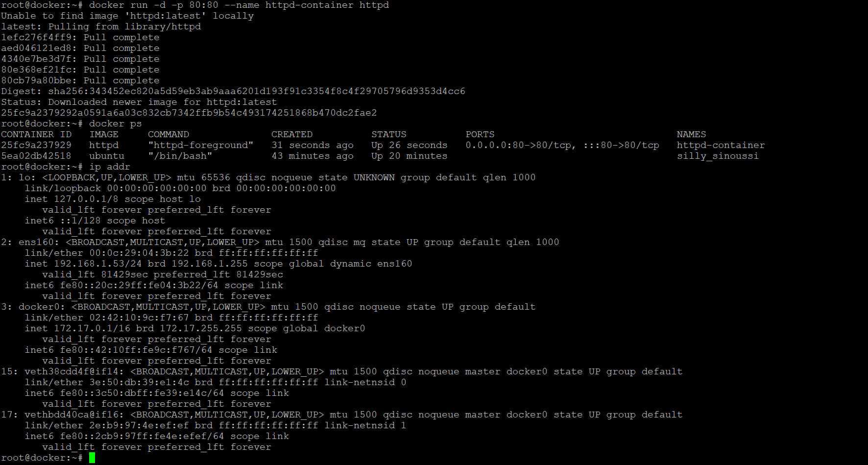

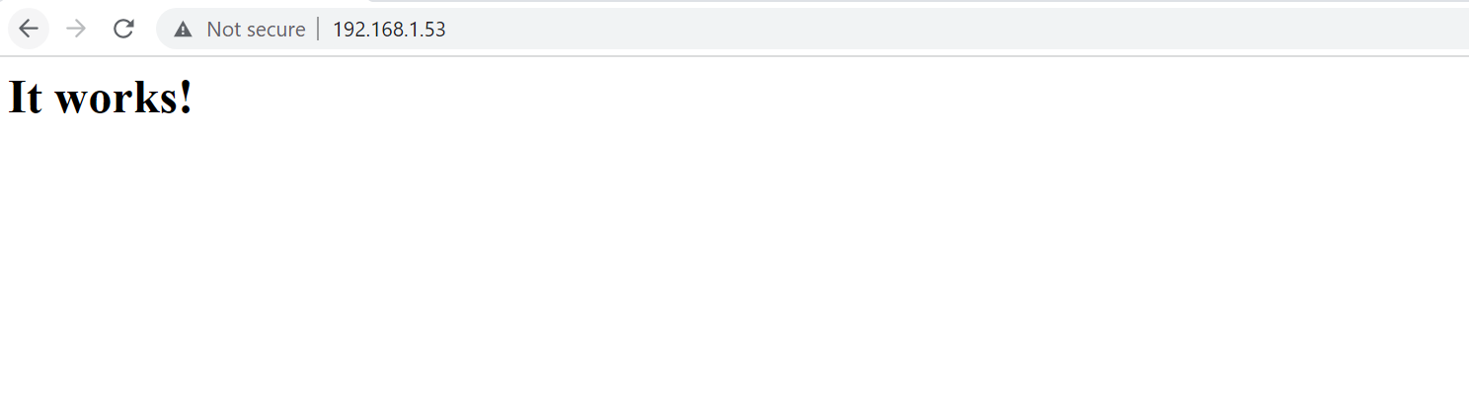

To map all the ports of a container, use the following command:-

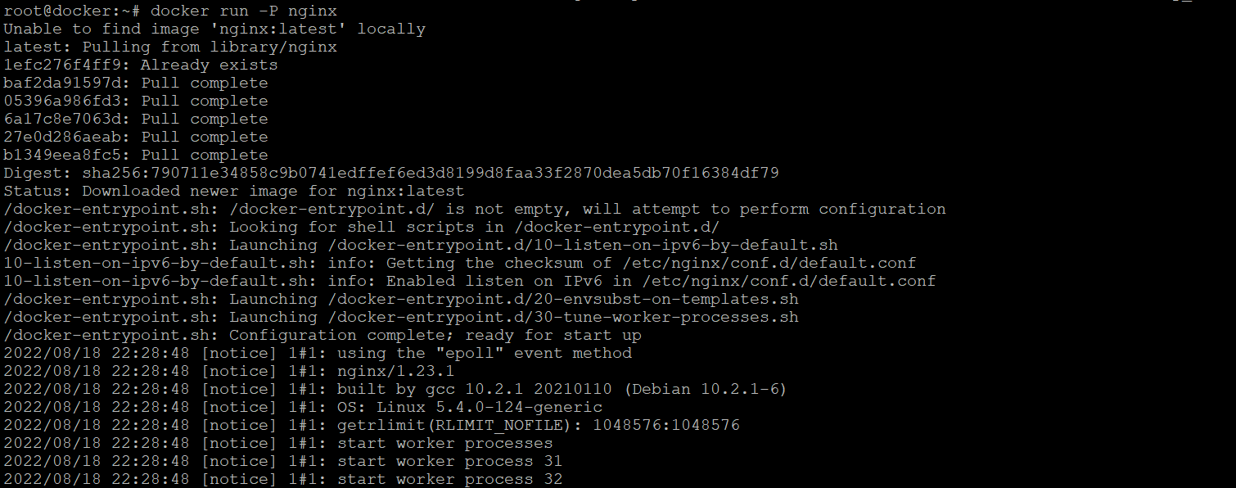

To copy the files from the container, use the following command;-

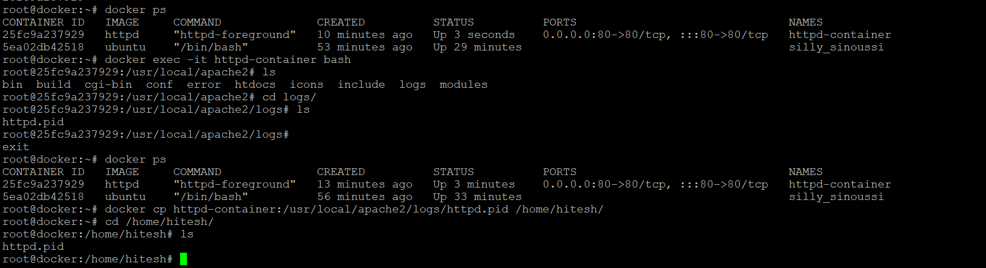

To copy a file from host to the container, use the following command:-



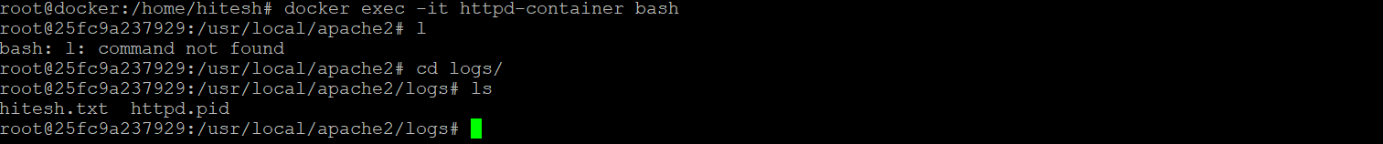

To pass an environment variable into the container along with the command, use the following command:-

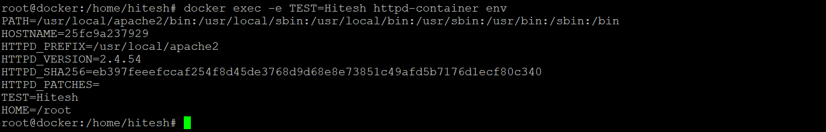

To pass the entire environment variable file, use the following command:-

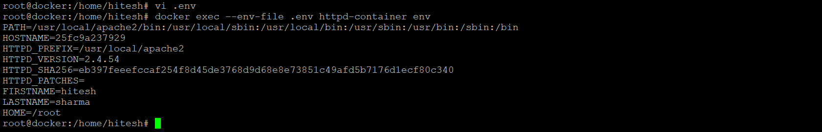



To run a command as a different user in the container, use the below command

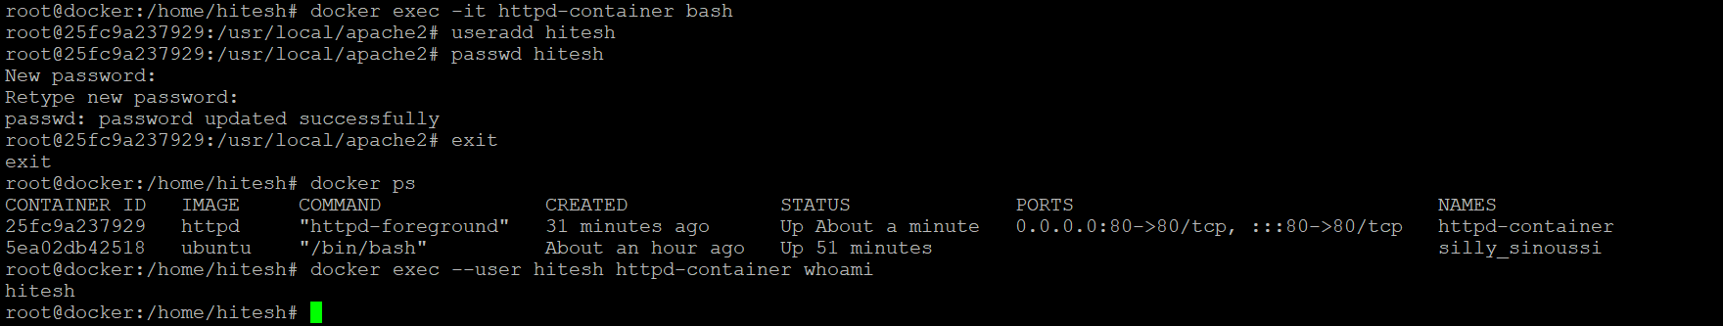

To run the commands in a alternative directory in a docker container, use the following command:-



To run a non-interactive command in docker container, use the following command:-

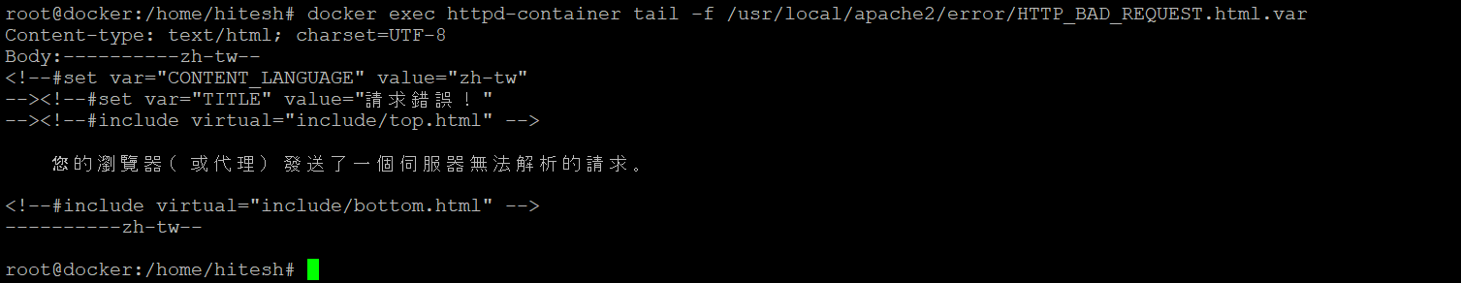

To rename a container, use the following command:-

